Tablets
# Source: Chatgpt (GPT-5-Mini) at [1/23/2026]
A tablet (or tablet computer) is a portable touchscreen device that combines features of a smartphone and a laptop. It’s larger than a smartphone but smaller and lighter than a laptop, and is designed mainly for media consumption, browsing, reading, and light productivity.

Tablets photo
# Source: Windows Screenshots (using Lightshot Program) at [1/23/2026]
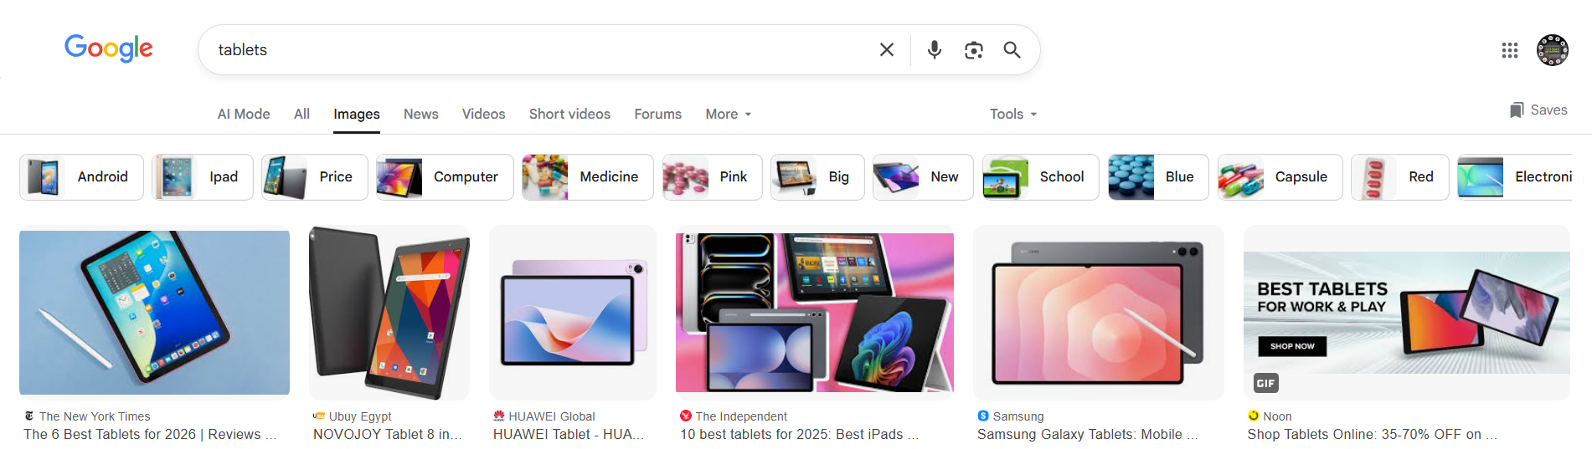

🔑 Key Features of Tablets:
# Source: Chatgpt (GPT-5-Mini) at [1/23/2026]
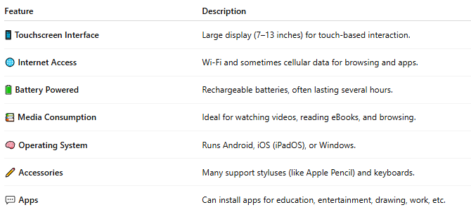

Feature | Description
📱 Touchscreen Interface | Large display (7–13 inches) for touch-based interaction.
🌐 Internet Access | Wi-Fi and sometimes cellular data for browsing and apps.
🔋 Battery Powered | Rechargeable batteries, often lasting several hours.
📚 Media Consumption | Ideal for watching videos, reading eBooks, and browsing.
🧠 Operating System | Runs Android, iOS (iPadOS), or Windows.
✏️ Accessories | Many support styluses (like Apple Pencil) and keyboards.
💬 Apps | Can install apps for education, entertainment, drawing, work, etc.

📲 Examples of Tablets:
# Source: Chatgpt (GPT-5-Mini) at [1/23/2026]
- Apple iPad (iPadOS)
- Samsung Galaxy Tab (Android)
- Microsoft Surface (Windows)
- Amazon Fire Tablet (Fire OS)

📱 Tablet vs Smartphone vs Laptop
# Source: Chatgpt (GPT-5-Mini) at [1/23/2026]
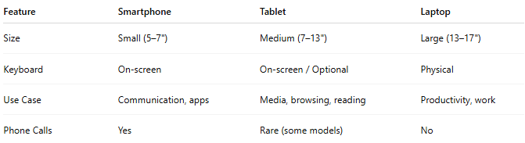

Feature | Smartphone | Tablet | Laptop
Size | Small (5–7") | Medium (7–13") | Large (13–17")
Keyboard | On-screen | On-screen / Optional | Physical
Use Case | Communication, apps | Media, browsing, reading | Productivity, work
Phone Calls | Yes | Rare (some models) | No

📖 Summary:
# Source: Chatgpt (GPT-5-Mini) at [1/23/2026]
A tablet is a portable, touch-based computing device designed for casual use and portability—perfect for reading, watching, browsing, and light work.

